http://brainiac2.mit.edu/isbi_challenge/downloads
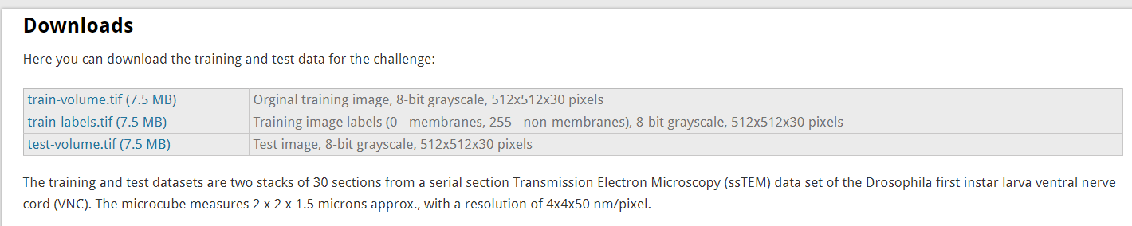

Nam: elesun8
Cod: elesun8

